<INSERT IMAGE HERE>  
(It should be representative to the gameplay and environment of the level)

Level Design Doc: <Around Pripyat>

<Game Name>

Version 1.0

|  |  |
| --- | --- |
| Designer: | <Author Name> |
| Document Date: | <Date Written> |
| Intended Level Delivery Date: | <Final Delivery Date> |

Table of Contents

Quick Summary 4

Goals 4

Gameplay Overview 5

General Game Flow 5

Major Elements 6

Objective Summary 6

Technical Overview 7

Campaign 7

Mission Location 7

Mission Difficulty 7

Mission Metrics 9

Level Details 10

Level Atmosphere/Mood 10

Major Characters/Vehicles 10

Gameplay Mechanics 10

Story 10

“60 seconds of gameplay” 11

Visual References 12

Terrain/Vegetation 12

Models/Architecture 12

Textures/Lighting 12

Characters/Vehicles 12

Maps 13

Callout A/1/etc.: <Description of callout> 14

Callout B/2/etc.: <Description of callout> 14

Callout C/3/etc.: <Description of callout> 14

References 15

**Be Sure to Update The Table of Contents after filling out the document**

# Quick Summary

*A single paragraph that describe the level including the following information*

* *Setting within the game world (Be as specific as you can, for example give a city name and region don’t just “a city somewhere”)*
* *Time period, both in relation to the rest of the game, and the overall story of the world (does it happen early or late in the campaign, where does it fall in relation to the major events of the world)*
* *A brief description of the overall gameplay for the level (it is a boss fight, a hold out, a search and destroy mission?)*
* *A brief description of the major goals and challenges the player will face. (Are there platforming challenges, resource management, do they have a limited amount of time, etc.)*
* *Finally include a single image that evokes* *the gameplay you are after, the environment is less important for this image than it was for the first one.*

Around Pripyat is a single player level, 2.5D built in the Unity engine. The level is set in a mix of tundra with swamp vegetation connecting to Pripyat, with has some Stalkers living and hunting around there, is not such an dangerous area, the kind of trouble most Stalkers found there is savage animals and some bandits. It will be a tutorial level, to player get into the mechanics and try to fight with some animals, player will have a machine gun and also can jump above enemies using his buster attack embedded on his shoes to kill any foe. If he suffer some attack will display a damage animation and the threat will run away to the horizont. His main object will be resumed to get into the main game mechanics and physics, (Except for the machine gun, with will exist only on this level), and reach the bar at the end, get a vodka and deliver to some stalkers sited around, they will play a song and after the player leaves the ambient to any side, he will suffer a fatal assault from some bandits and the level will end.

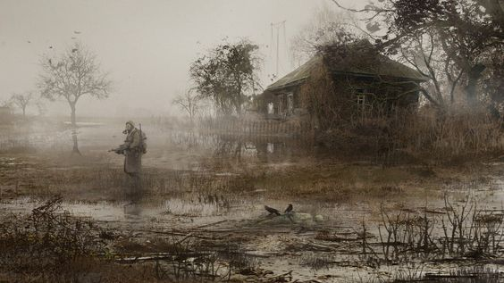

# Goals

*This should be a bullet or numbered list describing the high-level goals of the level. Basically, if you had to completely scrap your design and start over, what wouldn’t change? What are the core elements that must be present for this level, even if everything else shifts around them? Examples:*

1. *Introduce the turret and provide interesting gameplay centered around it*
2. *Amp the tension up from the previous level*
3. Introduce the new enemy type Streakers in a fun and not challenging, and non-threatening, environment, that plays to their strengths without overwhelming the player.
4. Introduce the machine gun and provide interesting gameplay centered around it
5. Amp up the tension and sense of darkness and oblivion to make player starts to understand the kind of atmosphere we want introduce to him.

# Gameplay Overview

A one to two paragraph introduction to the gameplay of the level. Questions to answer include, what are players trying to achieve? What are challenges they have to overcome to achieve it? What strategies/skills/equipment/etc. do they need to use to be successful? How can they fail? What happens when they succeed?

The gameplay focus is make player gets used with jump attack mechanics, maybe test his dodge attack and see what is armful to him. The only way to finish the level is continue going ahead until find the bar to get the drink to get back to his foes and enjoy a nice musical Ucranian campfire song event…. Before he dies.

## General Game Flow

*Describe the players movement through the level, where do they start and what order do they do things in? Include whether the level uses a linear beginning to end flow, a circular or braided flow, or is it more sandboxy without a defined flow?*

*Include 1 or more flow maps, showing the important areas of the level and the players path through them. Be sure to include a legend with each map that includes a map scale so readers can get a feeling for the size of your level.*

## 

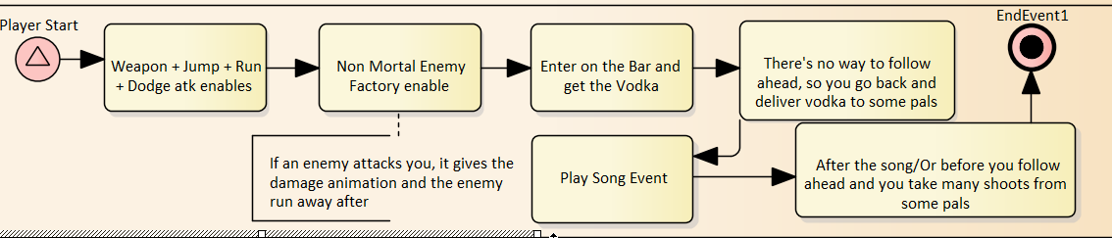

## Major Elements

*This should be a bulleted list that includes:*

* *The Hook – The one thing that is most memorable about the map and could possibly become a descriptor for the map (i.e. the asteroid level, the double jump level, low gravity funfest)*
* *WoW moments – Other particularly memorable moment that players will remember*
* *Story Beats – The major story elements that progress the narrative of the game*
* *New Gameplay – Any gameplay elements, tools, abilities, etc. that the player experiences for the first time in this level*
* *Important Visual Elements – What defines the visual style for this level or makes it stand out from the other levels in the game?*
* *The Hook – The guide though the post apocaliptc Slav atmosphere.*
* *WoW moments – The campfire song and the assassination moment.*
* *New Gameplay – Everything will b new around here, the main objective Is to make him fell familiar with the mechanics, when he see the enemy coming even having a gun (With will not be pointing forward) and even with this jump above the enemy (Like girls will do) it will gonna work.*
* *Important Visual Elements – The vegetation, the grass and the water on swamp must flow majestic, the environment wont will be so obscure like the rest of the game, so this level is basically turned to give the news player a good introduction.*

## Objective Summary

*How do players win and lose the level? Are there things players should do to better their chance of success? Should include a bulleted list of major objectives followed by a paragraph describing the objectives, fail states, and strategies the player can use.*

* *Don’t give up, if the player just press right button and walk, he will reach the bar.*
* *At the bar, he gets a vodka, that’s a must have*
* *Bring the vodka to the fellas outside.*
* *Than after that everything he can do will lead to the end of the stage. (Including keeping there waiting the end of the song).*

# Technical Overview

## Campaign

*Two paragraphs or bullet points*

1. *Describe the overall campaign that this level is a part of, what is the setting and story of the campaign?*
2. *Describe the levels overall position in the campaign. Does it come towards the beginning or the end? Why is it important to the overall campaign? What was happening in the story before the mission and what happens after it?*
3. *It will be on the main campaign of the path of the main character, and the major part of this campaign will be setted on this ambient (Including the next level).*
4. *It will be a short portion of the entire level, the level Around Pripyat will be showed entire like he must be when the player starts the next lvl.*

## Mission Location

*A bullet list to help readers get the feel for the level. Give a short sentence description of the*

* Theme – Are players running from something, defending something, attacking something?
* Mood – Is it a dark and gloomy level, or a tense level full of surprises, or a lighthearted level after a serious battle?
* Setting – Does it take place in a field, or an office building?
* Time of Day –
* Season –
* Weather –
* Theme – A cautious exploration into a daily and twisting tundra swamp
* Mood – Ominous and tense, but not overly threatening or evil
* Setting – The missions takes place entirely within these grassland with some abandoned houses
* Time of Day – A misty dark afternoon
* Season – Outumn
* Weather – Sunny but with some dark clouds

## Mission Difficulty

*Describe the mission difficulty for the beginning, middle and end of the missions on a 1 to 10 scale with 1 being easy and 10 being hard (be sure to include your scale so readers know what is hard and what is easy) Along with the numerical difficult give a one sentence description of the challenges causing the difficulty.*

*Absoluttelly easy-*

## Mission Metrics

* Play Time – (Estimated time for a normal player to complete in minutes)
* Physical Area – (Describe the dimensions of the level, can be in feet, meters, or editor units, just make not of what unit of measure you are using)
  1. Length:
  2. Width:
  3. Area:
* New Characters – List any new characters that show up during this level along with their important attributes and how they are used in the level.
* Visual Themes – List and briefly describe the different visual environment used in the level
  1. First visual theme
  2. Second visual theme
  3. Etc.
* Play Time – 10 minutes
* Physical Area – Plane.
* New Characters –

1. Rats
2. Player
3. Stalkers
4. Barman
5. Bandits (With will be identically the stalkers).

# Level Details

## Level Atmosphere/Mood

*What is the theme of the level and how do you plan to get it across to players? How do you want players to feel when playing this level and how do you plan to accomplish it?*

*Start with a paragraph describing the mood and how it changes throughout the level followed by a bullet point list of the features you plan to use to accomplish your goals. Also include how textures, lights, and sound affect the theme/mood.*

## Major Characters/Vehicles

*A Bullet point list of all of the characters and vehicles in the level including a short description of the character and what their role is in the level. List should include*

* *Player character*
* *Allies*
* *Mission Givers*
* *Enemies*
* *Other NPCs*
* *Important or interactive vehicles the player uses during the mission*

## Gameplay Mechanics

* Prerequisite Skills –
  + *(What does the player need to know before starting the level in order to be successful, include everything from basic mechanics like moving or jumping, to specialized skills learned in other levels that re-surface in yours)*
* Skills Learned –
  + *What does the player learn during your level in order to be successful?*

## Story

* Intro
  + *Describe the intro cutscene, mission briefing, or whatever else is used to introduce players to the level before they actually start playing.*
* In-Game
  + *This should be a bullet point list describing the actions players take throughout the level from beginning to end*
  + *Be as detailed as you can in describing all of the combat, puzzles, or interactions the player will go through.*
* Extro
  + *What happens when the player successfully beats the mission, describe the cutscene, debrief, or other outro used.*

## “60 seconds of gameplay”

*Give an exciting account of one roughly 60 second sequence of your level. Include voice lines and descriptions of action that evoke the feeling and gameplay of your level. Write in long form as if you were describing a movie scene.*

## Visual References

### Terrain/Vegetation

*If you have exterior environments include at least 3 to 4 reference images giving examples of the environment, vegetation, and terrain you expect*

### Models/Architecture

*If you have non-natural elements in your level, include at least 4 examples for what the buildings and other elements should look like.*

##### Textures/Lighting

*Provide at least 4 references for what you would like to see for wall/ground textures and level lighting.*

### Characters/Vehicles

*Provide at least 1 reference image for each character and vehicle you expect to use in the level including NPC’s and enemies.*

# Maps

*Include an over view map of the level and a series of detailed maps. The detailed maps should include:*

* *Lettered or numbered call outs for important gameplay encounters or moments*
* *Important enemy locations, spawn points, or paths*
* *Important pickups, powerups, or collectibles*
* *Important NPCs or interactable objects that players need to reach*

*Make sure every map has a legend and a scale so readers can interpret them.*

*(It may be useful to flip your page to portrait view to fit your map in)*

## Callout A/1/etc.: <Description of callout>

*This is a description of the first callout from your detailed maps Include a small image of the callout to help readers find it on the map and a brief description of what happens at this point.*

## Callout B/2/etc.: <Description of callout>

*These are just for the specific gameplay callouts, not everything on your detailed map*

## Callout C/3/etc.: <Description of callout>

*Repeat this for every callout in your detailed maps.*

# References

*Include links to where you found your various reference images and any other information you used when making your design such as lore pages or game world maps.*

